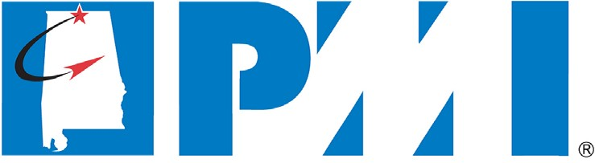
www.pmi-nac.org

PMI NORTH ALABAMA (PMI-NAC)
STRATEGIC PLAN
2019 - 2023
Version 5.0
July 2019

VERSION HISTORY

Version  # | Implemented By | Revision Date | Approved By | Approval Date | Reason
1 | Connie Wallace | 5/20/06 | PMI-NAC Board | 08/02/2006 | Initial Document
2 | Lourdes Godfrey | 4/25/10 | PMI-NAC Board |  | 2010 Update
3 | Ron Steele |  | PMI-NAC Board |  | Annual review
4 | Joe Paschall | 1/15/13 | PMI-NAC Board |  | 2013 Update
5 | Ron Upton | 3/27/2019 |  |  | 2019 Update

TABLE OF CONTENTS
- EXECUTIVE SUMMARY 4
- MISSION 4
- VALUE PROPOSITION 4
- ORGANIZATION PROFILE AND HISTORY 4
- CURRENT ENVIRONMENT 6
- CHAPTER OPERATING ENVIRONMENT AND ANALYSIS 7
- LONG-TERM STRATEGIC OBJECTIVES 8
- ANNUAL PLAN FOR 2013 8

EXECUTIVE SUMMARY
The PMI-NAC Strategic Plan aligns with the PMI Global Strategic Plan. The chapter derives its vision and mission from the PMI long term vision for project management, namely that, “Worldwide, organizations will embrace, value and utilize project management and attribute their success to it”. The PMI North Alabama Chapter (PMI-NAC) strategic plan defines the chapter’s commonly shared vision, mission, values and guiding principles. In addition, this plan provides the chapter leadership with a management tool for consistent direction, metrics and a picture of what success will look like in the future.

MISSION
To establish the foundation for its objectives and strategies the Board articulated the chapter mission as follows:
“To provide value to our members, communities, industries, and government — through professional development activities, outreach programs, and networking activities centered on project management.”

VALUE PROPOSITION
PMI-NAC intends to bring value to its members, partners and affiliates by:
  - Serving as a credible resource for Project Management knowledge, training, trends and practices in North Alabama.
  - Creating and offering additional services to its members including online forums, professional development, and employment opportunity synergy to increase value and opportunities for engagement.
  - Developing partnerships and strategic alliances with North Alabama organizations to provide members the opportunity to expand their personal networks, ideas, and practical application of PM skills through volunteerism, education, and sponsorship.
  - Promoting Project Management and the PMI-NAC brand. The chapter will pursue project-centric altruism through events including professional development days, and PM Days of Service (PMDoS); where the member population can volunteer to leverage their Project Management skills to assist local non-profit organizations in reaching their stated goals.
  - Developing and participating in community outreach programs whereby members may contribute their personal time, skills, and expertise to programs or events focused on improving the North Alabama communities in which we reside.
  - Providing cost-effective preparation for, and maintenance of, the PMI Family of Credentials.

ORGANIZATION PROFILE AND HISTORY
PMI-NAC is a component of PMI; an international professional association for project managers founded in 1969, PMI delivers value for more than 2.9 million professionals working in nearly every country in the world through global advocacy, collaboration, education and research. Since its original charter as the Tennessee Valley PMI Chapter in 1990, additional PMI Chapters have been established in Memphis, TN; Nashville, TN; Chattanooga, TN; Knoxville, TN; Atlanta, GA; Birmingham, AL; and Mobile, AL. In July 2002, the Chapter was incorporated in the State of Alabama and its name was officially changed to PMI – North Alabama Chapter (PMI-NAC) to better reflect the region that the chapter serves. PMI-NAC has experienced significant growth since its inception in 1990.

The chapter’s membership grew gradually through its first 14 years and ended 2004 with 131 members. Membership grew considerably over the next decade and ended 2018 with just over 830 members. The chapter’s membership growth reflects the increased value created by PMI-NAC for its members and the rapid growth of the local and surrounding areas, along with the profession of Project Management.

As of April 2019, the chapter has 893 members. The growth of the chapter over the last three years is illustrated in the membership chart below.

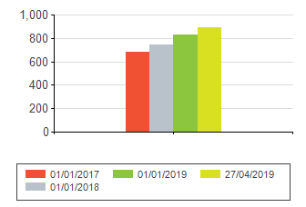
Membership Count

This growth also mirrors similar growth by PMI Global and reflects the success of PMI as a whole in promoting the benefits of project management and the benefits of credentialing.
PMI offers eight certifications that recognize knowledge and competency, including the Project Management Professional (PMP)® certification – renowned as the global gold standard. Salaries and career opportunities for PMPs show that employers recognize the value delivered by trained practitioners. PMI-NAC members maintain a good mix of credentials, as displayed below, with over 73% of members with PMI credentials.

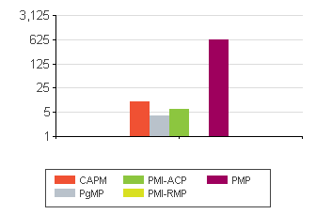
Membership Credential Breakdown

Credential | Credential Count
PMP ® | 629
CAPM ® | 10
PMI-ACP ® | 6
PgMP ® | 4
PMI-RMP ® | 1
Total | 650

Research by PMI Global indicates that individuals often drop their membership in PMI once they achieve their certification because the value proposition for maintaining the membership is no longer there. They can maintain their certification just as easily and less expensively without their PMI membership. This is a challenge the chapter attempts to address by offering high-quality, low-cost continuing education seminars incorporated in lunch and breakfast meeting formats to facilitate attendance and attract future members. Additionally, the chapter offers online special interest group meetings, membership socials for networking and camaraderie, an annual awards dinner, and PMP Prep Courses. As a result of this focused effort, PMI-NAC retention numbers have steadily increased over the last three years, as reflect in the chart below.

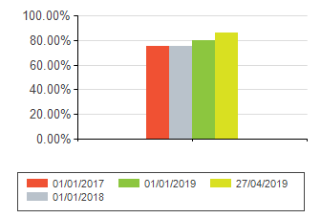
Member Retention

Meetings are offered throughout the month on a standard basis in an effort to provide predictability and facilitate ease in scheduling for our members.
- Breakfast meetings are held on the first Thursday of the month from 0730 – 0830, average attendance is 32.

- Lunch meetings are held on the third Tuesday of the month from 1130 – 1300, average attendance is 39.

- Online webinars are held on the fourth Thursday of the month from 1900-2000, average attendance is 32.

PMP Preparation Courses are offered twice per year, spring and fall. These courses run for eight weeks, meeting twice per week, and average 25 students per course.

An annual Project Management Excellence Awards Dinner is held where the chapter recognizes individuals and projects representing a commitment to the best practices in Project Management and exemplifying qualities of an excellent Project Manager.

On an ad-hoc basis, PMI-NAC hosts membership socials for networking and camaraderie. These events will target a specific subset of the membership, such as young professionals, new members, etc.

The chapter is always seeking new ways to increase the value proposition for our members and open to adding engagement opportunities.

CURRENT ENVIRONMENT

The north Alabama region benefits from numerous federal programs that are managed by the U.S. Army Redstone Arsenal, Army Corps of Engineers, Tennessee Valley Authority (TVA) and NASA Marshall Space Flight Center (MSFC). There is also an increasing purely commercial presence involved in non-governmental business activities, e.g. Toyota, Port of Huntsville, etc. The Board analyzes the major employers of our members compared to the major employers in our community.
Company | Number of Members
SAIC | 56
Yulista | 46
Intuitive Research and Technology | 38
Jacobs | 30
MTS | 25
The Boeing Company | 23
Northrop Grumman | 22
Dynetics Inc. | 14
Booz Allen Hamilton | 14
IBM | 13
DRS Technologies | 13
ADTRAN | 13

This comparison will help identify potential opportunities for corporate sponsorships as well as companies to reach out that may be under represented in our membership. To date, this approach has resulted in a 300% increase in corporate sponsorship. A chart showing this comparison is adjacent.

The chapter currently provides a variety of professional development opportunities, including monthly meetings, PMP Exam Preparation courses, online events and other special programs.

The challenge PMI-NAC faces is how to best meet the needs of a membership is involved in executing projects supporting a diverse group of Government and Commercial Organizations. The dilemma is demonstrated by the fact that, while PMI-NAC has over 900 members, there are as many non-member PMPs in our area. To address this challenge, the Board is expanding our professional development offerings and volunteer opportunities to increase the value to our current membership an engage non-member PMPs. Our next member survey will focus on assessing our new initiatives and validating our core activities and offerings to increase value and participation in PMI-NAC.

CHAPTER ORGANIZATION
The Board of Directors consists of the officers of PMI-NAC elected by the membership. There are eleven elected voting officers who serve in the following positions:
- Past President
- President
- President-Elect
- Vice President of Administration
- Vice President of Communications
- Vice President of Finance
- Vice President of Marketing
- Vice President of Membership
- Vice President of Programs
- Vice President of Professional Development
- Vice President of Volunteers
Board members conduct their assigned duties in accordance with the current By-Laws, approved by PMI Global.
The President, as well as Vice Presidents within their area of responsibility, may optionally appoint non- voting Directors (hereinafter “Director(s)”) to assume areas of responsibility or liaisons as deemed necessary. Examples include but are not limited to Academic Outreach Liaison, Committee Chairperson, or Special Events Director. The 2019 Board of Directors and appointed non-voting director positions are depicted in the figure below.

LONG-TERM STRATEGIC OBJECTIVES (5 Year)
1. These strategic objectives reflect our vision for PMI-NAC in 5 years, thru calendar year 2023. They reflect the Chapter’s desired 5-Year end state in fulfilling its mission statement. These objectives are not prioritized, but may be prioritized on an annual basis as determined by the Board of Directors. The means toward this end shall be reflected in annual planning meeting deliverables.
  - Membership – Grow the Chapter to 1,300 members.
  - Sponsorship – Increase sponsorship to sustain a minimum of $25,000 in corporate contributions annually.
  - Conduct two PMDoS with local NPOs annually, providing project management mentorship and assistance within the North Alabama Community.
  - Sustain no less than two PMP Prep courses annually; add at least one other PMI Credential prep course (i.e., PgMP, CAPM).
  - Conduct one professional development day (PD-Day) per quarter annually.
  - Provide the means for all board members to attend at least one PMI Global or Regional Leadership Institute Meeting (LIM) annually. Additionally, provide two additional slots for members in good standing who are identified as having potential to serve as future board members.
  - Establish a college scholarship program that provides $5,000 in scholarships annually to high school students who intend to continue their education in project management related curriculums.
2. Annual Goals. The following calendar year goals serve as a benchmark to track progress of the Chapter in achieving the long-term strategic objectives:

Calendar Year 2019
- Grow Chapter membership to 885 members.
- Obtain sponsorships to meet or exceed $5,000 in revenue.
- Conduct 1-2 PMDoS with local NPOs for the purpose of providing project management mentorship and assistance.
- Execute two PMP Prep Courses.
- Plan and execute one PD-Day.
- Fund two or more board members’ attendance at a PMI Global or Regional LIM.
- Develop and approve the college scholarship program plan for execution in CY 2020.

Calendar Year 2020
- Grow Chapter membership to 975 members.
- Obtain sponsorships to meet or exceed $10,000 in revenue.
- Conduct at least two PMDoS with local NPOs for the purpose of providing project management mentorship and assistance.
- Execute two PMP Prep Courses. Begin planning and resourcing one alternate PMI Credential prep course (PgMP, CAPM, Etc.) for execution in CY 2021.
- Plan and execute one PD-Day.
- Fund four or more board members’ attendance at a PMI Global or Regional LIM.
- Execute the college scholarship program with a minimum $1,000 scholarship.

Calendar Year 2021
- Grow Chapter membership to 1075 members.
- Obtain sponsorships to meet or exceed $15,000 in revenue.
- Conduct at least two PMDoS with local NPOs for the purpose of providing project management mentorship and assistance.
- Execute two PMP Prep Courses. Execute one alternate PMI Credential prep course (PgMP, CAPM, Etc.).
- Plan and execute two PD-Days.
- Fund six or more board members’ attendance at a PMI Global or Regional LIM.
- Execute the college scholarship program with a minimum of two, $1,000 scholarships.

Calendar Year 2022
- Grow Chapter membership to 1180 members.
- Obtain sponsorships to meet or exceed $20,000 in revenue.
- Conduct at least two PMDoS with local NPOs for the purpose of providing project management mentorship and assistance.
- Execute two PMP Prep Courses. Execute one alternate PMI Credential prep course (PgMP, CAPM, Etc.).
- Plan and execute three PD-Days.
- Fund eight or more board members’ attendance at a PMI Global or Regional LIM. Fund one member in good standing who is identified as having potential to serve as future board member.
- Execute the college scholarship program with a minimum of three, $1,000 scholarships.

Calendar Year 2023
- Grow Chapter membership to 1300 members.
- Obtain sponsorships to meet or exceed $25,000 in revenue.
- Conduct at least two PMDoS with local NPOs for the purpose of providing project management mentorship and assistance.
- Execute two PMP Prep Courses. Execute one alternate PMI Credential prep course (PgMP, CAPM, Etc.).
- Plan and execute four (quarterly) PD-Days.
- Fund all board members’ attendance (not including Past-President) at a PMI Global or Regional LIM. Fund two members in good standing who are identified as having potential to serve as future board members.
- Execute the college scholarship program with a minimum of five, $1,000 scholarships.

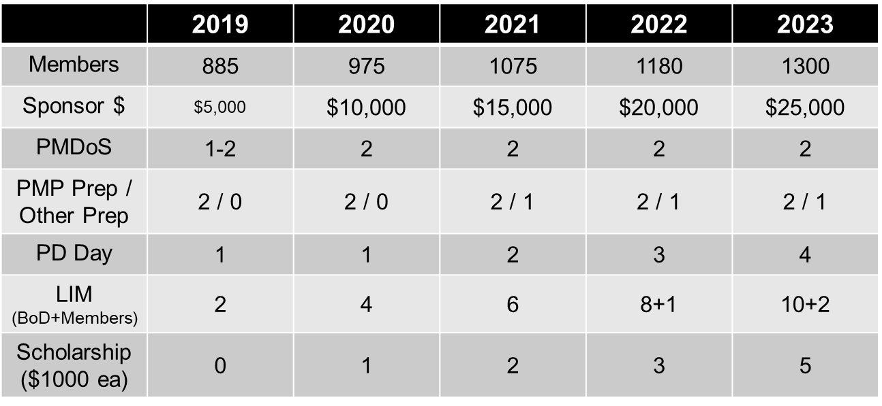
Long-Term Strategic Objectives Roll-Up

ANNUAL PLAN FOR 2019
An annual planning session (tentatively in May 2019) will address annual goals, objectives and means/methods that support this strategic plan.

9 CONCLUSION

This strategic plan is engineered for the Chapter to achieve its mission of providing value to our members, communities, industries, and government — through professional development activities, outreach programs, and networking activities centered on project management. It is a living document, and shall be reviewed on an annual basis to allow for changes necessary to maintain the strategy’s feasibility and suitability for execution. The 2019 annual review is scheduled in May, 2019 (TBD) as an off-site event. Updates to the strategy shall be published to the membership for transparency. In the event no updates are necessary, no publication is necessary. Board of Director approval by majority vote is required each calendar year following the annual review. The Long-Term Strategic Plan shall be posted on the PMI-NAC web site and available to members at all times.

The annual planning meetings required by PMI Global shall address the upcoming year’s detailed planning necessary for execution. This planning meeting’s focus is to address all resourcing, methods, and means required to execute the next calendar year plan, and is not intended to adjudicate this Long-Term Strategic Plan.

